Cloud Computing and Microsoft Azure

## What is Azure?

Azure is Microsoft's cloud computing platform, offering a wide range of services such as virtual machines, databases, AI, and more. It enables organizations to build, deploy, and manage applications and services in the cloud, providing scalability, flexibility, and cost-efficiency.

## Microsoft Azure Services

Microsoft Azure Services encompass a diverse set of cloud offerings, including Azure Virtual Machines, Azure App Service, Azure SQL Database, and Azure AI services. These services help businesses innovate, scale, and secure their operations in the cloud.

## What is cloud computing?

Cloud computing is the delivery of computing services (such as servers, storage, databases, networking, software, analytics, and intelligence) over the internet to offer faster innovation, flexible resources, and economies of scale. It allows users to access and manage IT resources without the need for extensive on-premises infrastructure.  
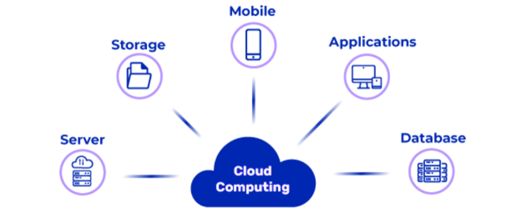  
Top benefits of cloud computing

Cloud computing offers benefits like:

* Cost Savings
* Scalability
* Agility
* Security
* Global Reach
* Enabling organizations to reduce infrastructure costs
* Quickly adapt to changing demands
* Enhance data protection

## Types of cloud computing

Cloud computing includes:

* Infrastructure as a Service (IaaS)
* Platform as a Service (PaaS)
* Software as a Service (SaaS)

## Types of cloud services: IaaS, PaaS, serverless, and SaaS

* IaaS (e.g., Azure VMs) provides virtualized hardware resources
* PaaS (e.g., Azure App Service) offers development platforms
* Serverless (e.g., Azure Functions) allows running code without managing servers
* SaaS (e.g., Office 365) delivers software applications via the cloud.

## Uses of cloud computing

Cloud computing is used for various purposes, including:

* Web hosting
* Data storage and backup
* Application development
* Big data analytics
* Machine learning
* Enabling businesses to manage resources and innovate efficiently

## Microsoft and cloud computing

Microsoft is a leading provider of cloud computing services through Azure. They have made significant investments in cloud infrastructure, AI, and IoT, helping organizations of all sizes leverage the cloud's power for innovation and digital transformation.

# Microsoft Azure Platform

## Azure Platform & History

Microsoft Azure is a comprehensive cloud computing platform that offers a wide range of services, including infrastructure, applications, and data solutions. It was launched in 2010 and has since grown to become one of the leading cloud providers worldwide.

### Microsoft Azure Support for Open Source

Azure actively supports open-source technologies, fostering collaboration with the open-source community. It offers a variety of tools, services, and integrations to help open-source developers leverage Azure's capabilities.

### Azure Momentum

Azure has experienced remarkable growth, with millions of customers and data centers in regions worldwide. Its momentum showcases its popularity and trustworthiness in the cloud computing industry.

### Azure Services

Azure offers a vast array of services, including:

* Computing
* Databases
* AI
* Analytics
* Enabling users to build, deploy, and manage applications across various domains.

## Configuring Visual Studio 2022

Configuring Visual Studio 2022 for Azure development involves setting up the development environment to seamlessly work with Azure services and resources.

### Download Visual Studio

To begin developing Azure applications in Visual Studio, you need to download and install Visual Studio, the integrated development environment (IDE) by Microsoft.

### Install Azure workloads

Install Azure workloads within Visual Studio to access Azure-specific tools and resources for developing and deploying cloud applications.

### Authenticate Visual Studio with Azure

Authenticate Visual Studio with your Azure account to enable seamless integration and management of Azure resources directly from the IDE.

Azure Global Infrastructure

## Regions

Azure regions are physical locations around the world where Microsoft Azure data centers are located. These regions allow customers to deploy and run their applications and services close to their target audience for improved performance and compliance.

## Geographies

Azure geographies are areas of the world containing multiple Azure regions that are close to each other, providing data residency and data sovereignty options. They are designed to offer high availability and disaster recovery options.

## Availability Zones

Azure Availability Zones are unique physical locations within an Azure region. These zones are designed to protect applications and data from data center failures by providing redundant power, cooling, and networking. They are isolated from one another to ensure fault tolerance.  
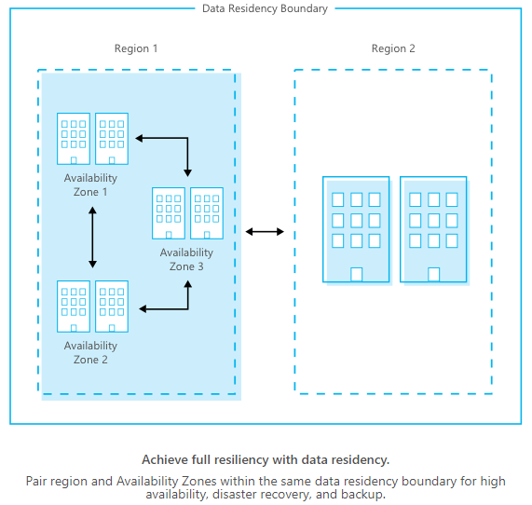

### Zonal Services

Zonal services in Azure are those that can be deployed to specific Availability Zones, providing high availability and fault tolerance. Examples include virtual machines and managed disks.

### Zone-Redundant Services

Zone-redundant services in Azure automatically replicate data and services across multiple Availability Zones, ensuring high availability. Azure SQL Database and Azure Blob Storage are examples of services that support zone redundancy.

### Regions that support Availability Zones

Not all Azure regions support Availability Zones. You can check which regions support them by referring to the Azure documentation or by using the Azure CLI.

### Services that support Availability Zones

Many Azure services support Availability Zones, such as Virtual Machines, SQL databases, and Load Balancers. You can find a complete list of these services in the Azure documentation or by using the Azure CLI to explore available options for your specific region and subscription.

Azure Virtual Machine

## Virtual Machines in Azure

Virtual Machines in Azure are powerful, cloud-based computing instances that enable businesses to run a wide range of operating systems and applications with high flexibility and control.

### Uses of Virtual Machines

Azure Virtual Machines serve as a versatile solution for tasks like:

* Hosting Websites
* Running Custom Applications
* Analyzing Data
* Providing Businesses with scalable and cost-effective resources

### Before Creating an Azure Virtual Machine

Prior to creating an Azure Virtual Machine, careful planning involving factors such as resource location, machine size, and operating system configurations is essential to ensure optimal performance and cost-efficiency.

### Location of Azure Virtual Machine

The location of an Azure Virtual Machine plays a crucial role in terms of data residency, availability, and latency. Choosing the right region is vital for an optimal user experience.

### Azure Virtual Machine Size

Selecting the appropriate VM size is critical in Azure to meet performance requirements and control costs. Azure offers a variety of VM sizes tailored to different workloads.

### Azure Virtual Machine Operating System Disks and Images

Azure provides a library of pre-configured operating system images and allows customization. Understanding how to manage OS disks and images is fundamental when setting up a VM.

### Extensions of Virtual Machine

Azure Virtual Machine extensions are add-ons that enhance functionality, security, and management. These extensions offer a seamless way to optimize your VM for specific tasks or roles.

### Creating Azure Virtual Machine in Azure Portal

The Azure Portal provides an intuitive interface to create and manage Virtual Machines. This streamlined process ensures ease of deployment and configuration for users.

## Azure Deployment Models

Azure offers various deployment models for hosting applications and services, including Azure Resource Manager (ARM), Azure Service Fabric, and Azure Kubernetes Service (AKS). Each model provides a different level of control and flexibility in managing your resources.

### Virtual Machines Series and Sizes

Azure provides a wide range of virtual machine (VM) series and sizes to cater to diverse workloads. You can choose from options like the D-series for general-purpose computing, F-series for compute-intensive tasks, and more, depending on your specific performance and cost requirements.

## Virtual Machine Architecture

Azure VMs come in both x86 and ARM architectures. You can choose the architecture that best suits your application's requirements, with x86 being the most common for general-purpose workloads and ARM designed for specific use cases like IoT and edge computing.

### Windows VM Disk Layouts

Windows VMs in Azure typically have a disk layout consisting of an operating system disk (C: drive) and additional data disks (D: drive, E: drive, etc.) for storing application data. The exact layout can be customized based on your requirements.

### Web Deployment

Azure offers various options for web deployment, including Azure App Service, Azure Functions, and Azure Kubernetes Service (AKS), allowing you to host web applications and APIs in a scalable and managed environment.

### Custom Domain

You can associate a custom domain with your Azure resources, such as Azure App Service, by configuring DNS settings and SSL certificates to make your application accessible via a user-friendly domain name.

### Data Sharing Between VMs

Azure provides multiple options for sharing data between VMs, such as using Azure File Storage, Azure Blob Storage, or setting up virtual network connections to allow direct data exchange between VMs.

Virtual Machines Scaling

## Azure Virtual Machines Scaling

Azure Virtual Machines Scaling is a feature that allows you to increase or decrease the number of virtual machines (VMs) that you are running in Azure. This can be done manually, or it can be automated using autoscaling.

### Auto-Scaling

Azure Auto-Scaling is a feature that monitors your VMs and automatically scales them up or down based on predefined rules. This can help you to ensure that your VMs are always able to handle the current demand, while also saving you money on your Azure bill.

### Vertical Scaling

Vertical Scaling is the process of increasing or decreasing the resources of a single VM, such as CPU cores, RAM, or storage. This can be useful for improving the performance of a VM that is handling a lot of load, or for reducing the cost of a VM that is not being used to its full potential.  
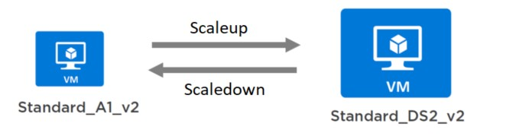

#### Scaling up

Increasing the resources of a VM.

#### Scaling down

Decreasing the resources of a VM.

### Horizontal Scaling

Horizontal Scaling is the process of adding or removing VMs from a group of VMs. This can be useful for handling increased demand, or for reducing costs when demand is low.

#### Scaling out

Adding VMs to a group of VMs.

#### Scaling in

Removing VMs from a group of VMs.

### Autoscale Settings

Autoscale Settings are the rules that you use to configure autoscaling for your VMs. These rules can be based on metrics such as CPU utilization, memory usage, or network traffic.

### Minimum Instance

The minimum number of VMs that you want to be running in your VM group, even when demand is low.

### Maximum Instances

The maximum number of VMs that you want to be running in your VM group, even when demand is high.

### Metric-based

Autoscaling rules that are based on metrics, such as CPU utilization, memory usage, or network traffic.

### Time-based

Autoscaling rules are based on a schedule, such as scaling out at 9 a.m. and scaling in at 5 p.m.

#### Scaling up requires downtime

Yes, scaling up a VM requires downtime while the VM is restarted with the new resources.

#### Scaling up will Increase performance but is not available

Yes, scaling up a VM will increase its performance, but it is not available on all Azure VM sizes.

#### Scale-Out doesn’t require downtime

No, scaling out a VM group does not require downtime. Azure will automatically add new VMs to the group and start them up without impacting the existing VMs.

#### Scale-Out, Increase performance and availability as well

Yes, scaling out a VM group will increase the overall performance and availability of the group. This is because the load will be distributed across multiple VMs.

## Data Disk

A data disk is a virtual hard disk that can be attached to a VM. Data disks are used to store data, such as operating systems, applications, and application data. Data disks can be either temporary or persistent. Temporary data disks are deleted when the VM is restarted, while persistent data disks are retained even after the VM is restarted.

Highly Available Virtual Machines

## Availability Sets

Availability Sets in Azure ensure high availability by distributing virtual machines across separate physical hardware. This prevents single points of failure by placing VMs in different faults and updating domains within a data center.

## Fault Domains

Fault Domains are logical groupings within an Azure data center that represent separate physical hardware. Distributing VMs across different fault domains reduces the risk of simultaneous hardware failures affecting multiple VMs.  
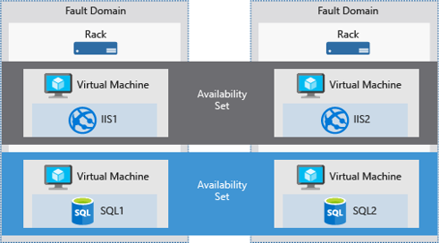

## Update Domains

Update Domains are logical groupings within an Availability Set, ensuring that not all VMs are updated simultaneously during maintenance. Azure automatically updates VMs in different update domains, preserving application availability.  
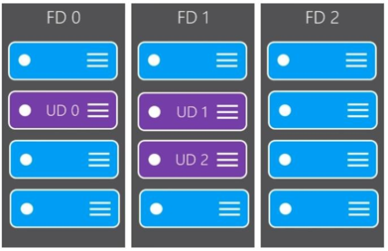

## Creating High Available VM

To create a highly available VM in Azure, place it in an Availability Set. This configuration ensures that your VMs are distributed across fault and update domains to maximize uptime and minimize downtime during maintenance or failures.

## Architecture for N-Tier Application

Designing a high-availability N-tier application in Azure involves using multiple Availability Sets for each tier (web, app, database) and load balancers to distribute traffic. Combining Azure services like Virtual Machines, Azure App Service, and Azure SQL Database can create a robust and scalable architecture.

Azure Storage

## Benefits of Azure Storage

* Scalable Cloud Data Storage
* Secure Data Storage
* Cost-Effective Solution
* Global Data Access
* Automatic Backup
* Integration with Azure Services
* Efficient Data Management
* High Availability
* Data Redundancy

## Azure Storage Data Services

Azure Storage data services encompass a wide range of offerings, including Blob Storage for unstructured data, Azure Files for simplified file sharing, and Queue Storage for building robust, cloud-native applications. These services provide a versatile platform for various data management needs.  
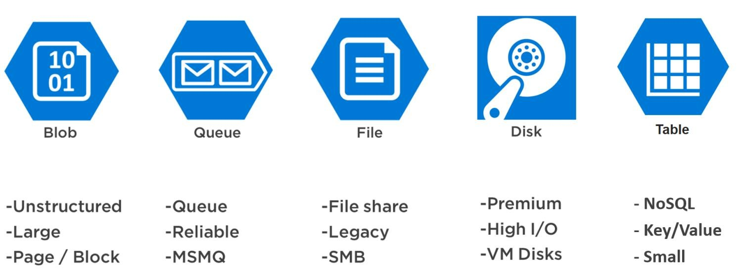

### Review Options for Storing Data in Azure

When considering Azure as your data storage solution, carefully evaluate options such as Blob Storage for multimedia content, Azure Files for cross-platform sharing, and Azure NetApp Files for high-performance workloads. This assessment ensures the most suitable choice for your specific data requirements.

### Sample Scenarios for Azure Storage Services

Azure Storage is versatile, supporting diverse use cases. For instance, Blob Storage can store web app data, Azure Files facilitates shared team resources, and Azure Disk Storage is ideal for configuring virtual machines, demonstrating the platform's adaptability.

### Blob Storage

Azure Blob Storage is a scalable and secure solution for storing unstructured data, including images, videos, and documents in the cloud. It offers tiered storage options to optimize costs and performance.

### Queue Storage

Azure Queue Storage is a reliable messaging service, that ensures seamless communication between different components of cloud applications. It's used for building resilient and decoupled architectures.

### Table Storage

Azure Table Storage is a NoSQL data store, tailored for semi-structured data. It offers excellent scalability and flexibility, making it suitable for applications with evolving data schemas.

### Disk Storage

Disk Storage in Azure is designed for persisting data in virtual machine environments. It provides high-performance options, including solid-state drives (SSD) and hard disk drives (HDD), with various redundancy levels.

## Azure Files

Azure Files simplifies cross-platform file sharing, making it ideal for applications requiring shared access to files and data. It seamlessly integrates with Azure AD for secure access control.

## Azure Elastic SAN (Preview)

Azure Elastic SAN is a high-performance block storage solution in preview, offering the scalability and performance required by enterprise workloads. It provides a reliable option for data-intensive applications.

## Azure NetApp Files

Azure NetApp Files provides high-performance file storage solutions for enterprises. It ensures consistent performance, data management capabilities, and integration with Azure services.

## Types of Storage Accounts

Azure offers different types of storage accounts, including:

* General Purpose
* Blob Storage
* Premium

Each caters to specific storage needs and features like hot/cold tiers.  
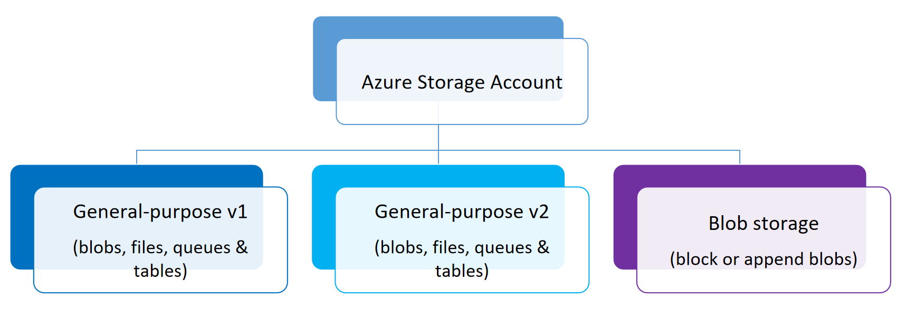

## Secure Access to Storage Accounts

Azure Storage ensures secure access through Azure Active Directory integration and Role-Based Access Control (RBAC). These measures bolster data security by controlling access at both the account and data level.

### Encryption

Azure Storage offers encryption at rest and in transit, safeguarding data privacy and compliance with industry standards. Data is encrypted using encryption keys managed by Azure or customer-managed keys.

### Redundancy

Azure Storage provides redundancy options like LRS, GRS, and ZRS, enhancing data resilience and availability, even in the event of hardware failures or regional outages.  
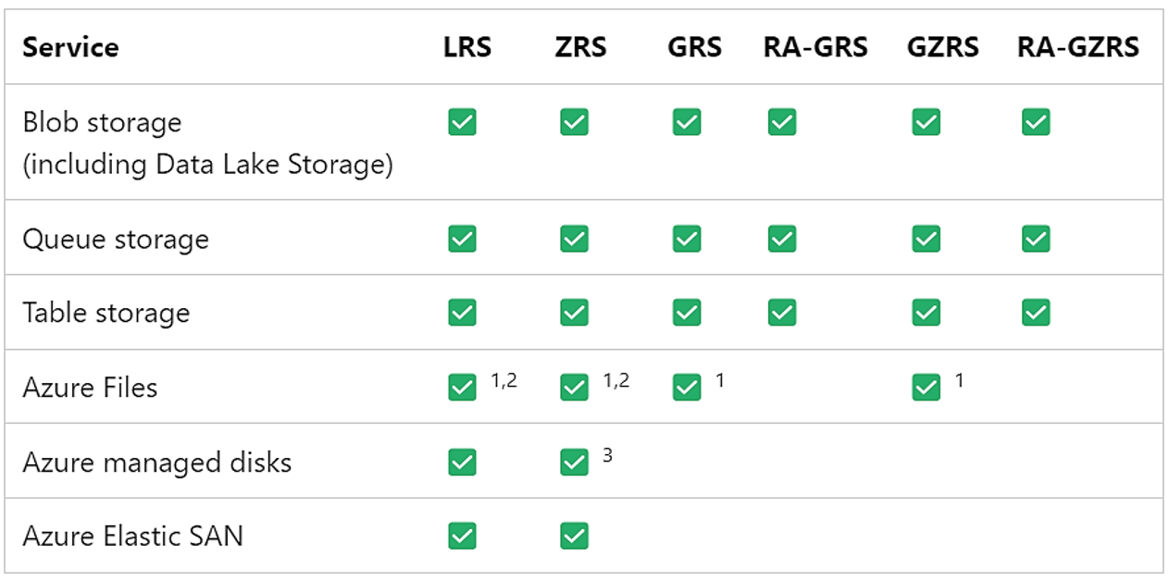

## Transfer Data to and from Azure Storage

Azure offers various tools such as Azure Data Factory, Azure Data Box, and AzCopy for efficient data migration and synchronization, simplifying the process of moving data to and from Azure Storage.  
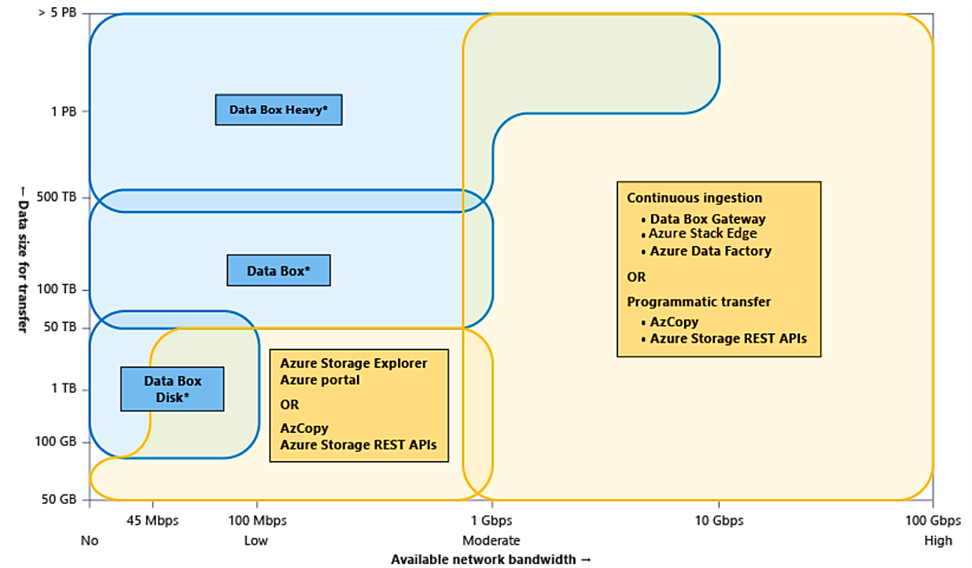

## Pricing

Azure Storage offers flexible pricing options, including pay-as-you-go, reserved capacity, and tiered storage, allowing businesses to optimize costs based on their storage needs and usage patterns.

## Storage APIs, Libraries, and Tools

Azure Storage boasts a rich ecosystem of APIs, libraries, and tools that empower developers to interact with the platform effectively. These include REST APIs, SDKs, and third-party integrations for seamless data management.

Storage Services

## What is a Storage Service?

Azure Storage service is a highly scalable and secure cloud storage solution that allows you to store and manage a wide variety of data, including files, blobs, tables, queues, and disks. It provides the foundation for data storage in Microsoft Azure and enables you to seamlessly integrate data into your applications.

## Why Do I Need an Azure Storage Account?

An Azure Storage account is essential for various purposes, including data backup, application data storage, website hosting, and media distribution. It offers the flexibility to choose the type of storage services required for your specific application needs while ensuring reliability, redundancy, and scalability.

### Disadvantages of Cloud Storage

* Data Security Concerns
* Potential Downtime
* Dependency on Internet Connectivity
* Cost Management Challenges
* Data Regulation Compliance

## What is Azure Blob Storage?

Azure Blob Storage is a service for storing unstructured data, such as documents, images, and videos. It is ideal for content distribution, backup, and archiving. Blobs are organized into containers, and you can access them via REST APIs.

### Components of Azure Blob Storage

Components of Azure Blob Storage

* Containers
* Blobs

Storage Tiers in Azure Blob Storage

* Hot Tier
* Cool Tier
* Archive Tier

## What is Azure File Storage?

Azure File Storage provides shared file storage for applications in the cloud. It is similar to a traditional file share and is useful for sharing data between multiple virtual machines or on-premises systems.

### Components of Azure File Storage

Components of Azure File Storage

* File Shares
* Directories
* Files

Accessing Azure File Storage

* SMB Protocol
* REST Protocol

## What is Azure Disk Storage?

Azure Disk Storage offers block-level storage for virtual machines, enabling you to attach disks to VMs for operating systems, data, or temporary storage. It ensures high availability and durability.

### Types of Disk Storage

Azure Disk Storage Types are as follows:

* Standard HDD
* Standard SSD
* Premium SSD
* Ultra Disk

## What is Azure Queue Storage?

Azure Queue Storage is a messaging service for asynchronous communication between application components. It helps decouple application components and enables reliable message processing.

### Components of Azure Queue Storage

The components of Azure Queue Storage are as follows:

* Queues
* Messages
* Metadata

## What is Azure Table Storage?

Azure Table Storage is a NoSQL data store that provides a key/attribute store with a schema-less design. It's suitable for semi-structured data and can handle massive amounts of data.

### Components of Azure Table Storage

The components of Azure Table Storage are as follows:

* Tables
* Entities
* Properties

## Storage Explorer Tool

Azure Storage Explorer is a graphical user interface tool that allows you to manage and interact with Azure Storage services. It simplifies tasks like uploading, downloading, and organizing data in your Azure storage accounts.

## How Can I Create Azure Storage Services?

You can create Azure Storage services through the Azure Portal, Azure PowerShell, Azure CLI, or various programming languages by using Azure SDKs. Select the desired service (e.g., Blob, File, Disk, Table, Queue) and configure its settings.

### Static Website Hosting

Azure allows you to host static websites using Azure Storage, providing a cost-effective and scalable solution for serving web content. You can easily configure static website hosting through Azure Portal or CLI.

## Azure CDN

Azure Content Delivery Network (CDN) is a global network of data centers that caches and delivers content closer to end-users, reducing latency and improving load times. It accelerates the delivery of web content and applications to enhance user experiences.

Understanding Azure SQL Database

## What is Microsoft Azure SQL Database?

Microsoft Azure SQL Database is a fully managed, cloud-based relational database service that leverages the power of Azure's global infrastructure. It provides a scalable and cost-effective solution for hosting your SQL Server databases in the cloud, offering features like automated backups, high availability, and compatibility with existing SQL Server applications.  
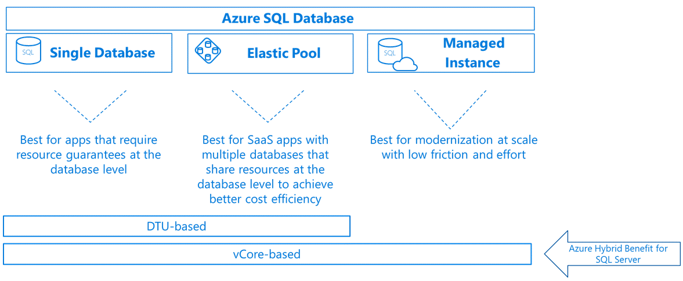

## Azure SQL vs. SQL Server

Azure SQL, as a cloud-native database service, differs from traditional SQL Server in its scalability, cost-efficiency, and built-in cloud capabilities. While SQL Server is typically run on-premises or in virtual machines, Azure SQL offers serverless, fully managed options for organizations looking to modernize their data infrastructure.

## SQL Azure Architecture

SQL Azure's architecture is designed for high availability, security, and global reach. It spans multiple Azure data centers, providing fault tolerance and low-latency access. It leverages Azure's infrastructure to ensure data integrity and offers a wide range of security features for data protection.

## Microsoft Azure SQL Database Pricing

Microsoft Azure SQL Database offers flexible pricing models, including serverless, provisioned, and managed instances, enabling users to choose a pricing structure that aligns with their specific workloads and budget constraints.

## Azure SQL Database Service Tiers

Azure SQL Database offers various service tiers, from Basic to Premium, each with different performance and scaling capabilities. These tiers allow users to select the most suitable configuration to meet their application's requirements while optimizing costs.

### SQL Database Logical Server

SQL Database Logical Server simplifies database management by grouping multiple databases together under a common server. It allows for centralized security and management of databases, making it easier to oversee and maintain a suite of databases.

### Elastic Pools

Elastic Pools in Azure SQL Database provide a cost-efficient way to manage and allocate resources among multiple databases with varying workloads. This shared resource model allows for improved resource utilization and cost optimization for organizations running multiple databases.

### Creating an Azure SQL Database using Azure Portal

Creating an Azure SQL Database through the Azure Portal is a straightforward process. Users can easily provision and configure databases, select the desired service tier, and set up security, connectivity, and other parameters through a user-friendly interface.

## Azure SQL Database Features

Features of Azure SQL Database are as follows:

* Advanced Security Capabilities
* Automated Tuning
* Intelligent Performance Insights
* Data Protection Tools

## Database Deployment Models

Azure SQL Database supports various deployment models, such as single databases and managed instances, allowing organizations to choose the best option based on their application requirements and migration strategies.

### Azure SQL Database Server

An Azure SQL Database Server is a logical container that hosts one or more SQL databases. It provides a management boundary for databases and simplifies administrative tasks like access control, firewall rules, and auditing.

### Database Deployment Options

Azure SQL Database offers flexible deployment options, including self-managed databases and platform-managed databases. These choices empower users to determine the level of control and automation they need for their database workloads in the cloud.

Single Database

## Introduction to Single Database

Azure's Single Database is a fully managed, cloud-based SQL database service that offers seamless deployment and management of individual databases. It ensures data reliability and high availability while eliminating the complexity of infrastructure management.

### Dynamic Scalability

Azure SQL Database's dynamic scalability feature enables businesses to easily adjust database performance and resource allocation based on real-time needs. This allows for optimal performance during peak usage while controlling costs during off-peak periods.

### Single Databases and Elastic Pools

Azure SQL Database provides the flexibility to choose between Single Databases and Elastic Pools for managing multiple databases. Elastic Pools offer a cost-effective solution for sharing resources among databases while maintaining performance isolation.

### Monitoring and Alerting

Azure SQL Database includes robust monitoring and alerting tools that enable real-time tracking of database performance, resource utilization, and potential issues. This proactive management helps maintain optimal database performance.

## Availability Capabilities

Azure SQL Database offers high availability features, including automatic failover and geo-replication, to ensure constant accessibility and data protection in the event of unexpected incidents.

## Transact-SQL Differences

Azure SQL Database is similar to on-premises SQL Server, but it may have specific differences in Transact-SQL commands and behavior due to the cloud-native environment. Understanding these distinctions is crucial for effective database management.

### Security

Azure SQL Database provides a range of security features, such as advanced threat protection, encryption, and authentication, to safeguard your data and ensure compliance with industry standards and regulations.

### Purchasing Models

Azure SQL Database offers various purchasing models, including provisioned and serverless, allowing you to choose the pricing and resource model that best suits your specific workload and budget.

## Introduction to the DTU Model

The DTU (Database Transaction Unit) model in Azure SQL Database measures the performance level of your database using a combination of CPU, memory, and I/O. Understanding the DTU model is essential for effectively provisioning resources.

### Creating Azure SQL Database

Creating an Azure SQL Database is a straightforward process that involves selecting the desired configurations, such as pricing tier, resource allocation, and region, to meet your database requirements. This initial setup is the foundation for your cloud-based SQL database.

Accessing Azure SQL Database

## Azure SQL Database Tools

Azure SQL Database Tools is a comprehensive suite of integrated services and features designed to optimize the management and development of Azure SQL Databases. It leverages the latest Azure technologies to streamline database administration, offering advanced monitoring, security, and scalability for your cloud-based SQL databases.

## SQL Server Management Studio (SSMS)

SSMS is the go-to tool for managing SQL Server databases on Azure and beyond. Its latest version boasts enhanced Azure integration, enabling seamless control and administration of SQL Server instances in the Azure cloud. With advanced features for database performance tuning and monitoring, SSMS simplifies the management of your Azure SQL resources.

## Azure Data Studio

Azure Data Studio, the cutting-edge data management tool, provides a unified, cross-platform experience for working with Azure services and databases. Its latest enhancements focus on deepening integration with Azure, making it an indispensable tool for Azure Data professionals. It offers a modern, intuitive interface for developing, debugging, and optimizing your Azure-based databases and data pipelines.

## .NET Application

Developed using the latest .NET technologies, .NET applications seamlessly harness the power of Azure services for scalability, security, and performance. By leveraging Azure's robust cloud infrastructure, .NET applications can effortlessly scale to meet changing demand while taking advantage of Azure's extensive toolset for enhanced deployment, monitoring, and management.

Single Database: vCore Model

## Introduction to vCore Model

The vCore Model in Azure represents a modern approach to database provisioning, offering enhanced flexibility and scalability. It allows you to precisely allocate computing power with virtual cores, ensuring optimal performance for your workloads while aligning with your specific resource requirements.

## vCore Compute Tiers

Azure's vCore Compute Tiers provide a diverse range of options for customizing your database performance. From the cost-effective Basic tier to the high-performance Premium tier, these compute tiers allow you to select the right level of resources to meet the demands of your applications, all while benefiting from Azure's robust infrastructure and advanced capabilities.

## Switching between DTU and vCore Model

Transitioning between DTU and vCore models in Azure is seamless, empowering you to adapt your database deployment as your needs evolve. Whether you're migrating from the legacy DTU-based provisioning or looking to fine-tune resource allocation with vCores, Azure's flexible options enable you to easily switch between models without data migration complexities.

Azue SQL Business Continuity

## Geo-replication

Azure's Geo-replication feature ensures high availability and disaster recovery by replicating your data across multiple Azure regions. This helps safeguard your critical data against regional outages and provides redundancy for uninterrupted access and operation.

### Data Protection and Auditing

Azure offers robust data protection and auditing tools, including encryption, access controls, and comprehensive auditing features. These safeguard your data from unauthorized access and provide valuable insights into data usage and security compliance, ensuring regulatory requirements are met.

### Features that Provide Business Continuity

Azure Business Continuity Features are as follows:

* Automatic Failover
* High Availability Configurations
* Geo-Replication

### Recover a Database Within the Same Azure Region

Azure enables you to quickly recover a database within the same Azure region, ensuring minimal data loss and downtime. This capability is crucial for ensuring data integrity and service availability in the event of database issues.

### Compare Geo-replication with Failover Groups

Geo-replication and failover groups are two different approaches to achieving high availability in Azure. Geo-replication focuses on data redundancy across multiple regions, while failover groups primarily address automatic failover within the same region, each with distinct advantages and use cases.

### Recover a Database to the Existing Server

Azure allows you to recover a database from its existing server, simplifying the restoration process and reducing complexity. This feature ensures that you can quickly revert to a known state without the need for extensive server reconfiguration.

### Upgrade an Application with Minimal Downtime

Azure's application deployment and scaling capabilities, along with features like Azure Traffic Manager and Azure Load Balancer, enable organizations to upgrade applications with minimal downtime. This ensures that end-users experience minimal disruption while enjoying the benefits of enhanced application functionality or performance.

Database Migration

## Azure Database Migration Service

Simplify and accelerate your database migration journey with Azure Database Migration Service. Seamlessly move your local databases to the cloud, benefiting from comprehensive security and compliance features, all while minimizing downtime.

### Introduction to Data Migration Assistant

Begin your data migration project confidently with the Data Migration Assistant in Azure. Assess your SQL Server databases before migration, automate the process, and leverage built-in security and compliance, ensuring a smooth transition to Azure SQL.

### Migrating Local Database to Cloud

Transitioning your local databases to the cloud has never been easier. Azure's two-step migration process and Azure Data Studio make it a breeze. Execute a complete migration with minimal downtime while moving widely used databases, all while enjoying the benefits of Azure's robust security and compliance features.

Elastic Pool

## What are SQL Elastic Pools?

Azure SQL Elastic Pools provide a cost-effective and scalable solution for managing multiple SQL databases with varying workloads. They allow you to share resources and reduce costs by pooling together databases while ensuring optimal performance and flexibility.

### Creating an Elastic Pool

Easily create an Azure SQL Elastic Pool to consolidate databases and improve resource utilization. With just a few clicks in the Azure portal, you can set up a pool that accommodates your databases' changing demands, simplifying management.

## When to Consider a SQL Database Elastic Pool?

Consider using a SQL Database Elastic Pool when you have multiple databases with varying usage patterns and want to optimize resource allocation and control costs effectively. Elastic Pools are ideal for applications with fluctuating workloads.

## How Do I Choose the Correct Pool Size?

Selecting the right Elastic Pool size is crucial for balancing performance and cost. Azure offers various performance tiers, and your choice should align with your databases' resource needs. Use Azure's monitoring tools to fine-tune your pool size as workloads change.

### Use Other SQL Database Features with Elastic Pools

Leveraging Azure SQL Database Features are as

* Geo-Replication
* Automated Backups
* Advanced Security

### Create a New SQL Database Elastic Pool by Using the Azure Portal

With the Azure portal, creating a new SQL Database Elastic Pool is a straightforward process. Follow a user-friendly interface to define your pool's characteristics, customize resource allocation, and get started with optimized database management.

### Monitor an Elastic Pool and Its Databases

Effortlessly keep tabs on the performance and health of your SQL Elastic Pool and its constituent databases. Azure's monitoring and alerting tools provide valuable insights, helping you maintain optimal resource utilization and responsiveness.

Managed Instance

## Introduction to Managed Instance

Azure's Managed Instance is a cutting-edge database service, that provides a seamless transition for SQL Server applications to the cloud. It offers the advantage of staying up-to-date with the latest SQL Server versions while ensuring robust security and compliance, all within a fully isolated environment.

## Creating Managed Instance

With Azure, creating a Managed Instance is a streamlined process that enables you to quickly and easily migrate your SQL Server applications to the cloud. It ensures optimal price performance, lowering your costs while maintaining SQL Server compatibility, increasing database administrator productivity, and offering comprehensive security and compliance features right out of the box.

Understanding Azure Cosmos DB

## What is Azure Cosmos DB?

Azure Cosmos DB is a globally distributed, multi-model database service provided by Microsoft Azure. It allows developers to build highly responsive and scalable applications by offering support for various data models, including document, key-value, graph, and column family. With its global distribution capabilities, it ensures low-latency access to data across the world.  
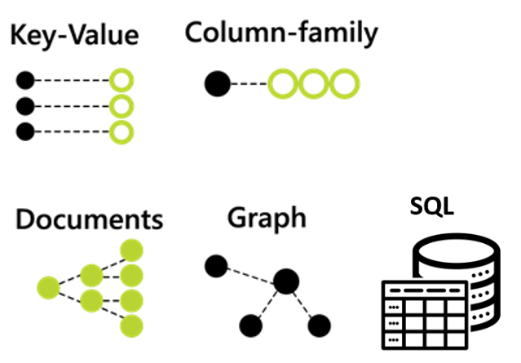

### Key Benefits of Azure Cosmos DB

* Limitless Scalability
* Global Distribution
* Guaranteed Low-Latency Performance
* Comprehensive SLAs
* High Availability
* Throughput
* Consistency
* Flexibility in Data Modeling
* Microsoft's Security and Compliance Standards

## How Does It Work?

Azure Cosmos DB employs a multi-master, globally distributed architecture. It replicates data across Azure regions and offers tunable consistency levels, enabling developers to balance performance and data consistency. It uses automatic and instant scalability, along with built-in support for popular APIs, like MongoDB, Cassandra, SQL, and more, to simplify development.

## How Data Is Provisioned?

Data provisioning in Azure Cosmos DB is straightforward. You can create containers and define the partition keys to distribute data across physical partitions. You can choose manual or autopilot modes for throughput provisioning and effortlessly scale your resources up or down to meet application demands.

### Backup and Restore

Azure Cosmos DB provides continuous backups and point-in-time restores, ensuring data durability and recoverability. Backups are automated and retain data for a configurable period, allowing you to restore your data to any specific point in time within that window.

## Common Use Cases

#### Ideal Use Cases for Azure Cosmos DB:

* Global Reach
* High Availability
* Low-Latency Data Access

#### Common Scenarios:

* Real-time IoT Data Ingestion
* E-commerce Applications
* Content Management Systems
* Gaming Leaderboards

### Easily Migrate Your SQL Server Apps to the Cloud

Azure simplifies the migration of your SQL Server applications to the cloud, providing a hassle-free transition. By seamlessly shifting your workloads, you can unlock the benefits of cloud computing while maintaining operational continuity.

### Always Operate on the Latest Version of SQL

Azure's Managed Instance ensures you're always working with the most up-to-date SQL Server version. This means you can take advantage of the latest features, enhancements, and security updates without the hassle of manual upgrades.

### Optimize Price-Performance and Lower Your Costs

Azure's Managed Instance optimizes the balance between price and performance. It helps you achieve cost savings while ensuring your SQL workloads run efficiently in the cloud.

### Maintain SQL Server Compatibility

While moving to the cloud, you don't have to sacrifice SQL Server compatibility. Azure's Managed Instance guarantees your applications continue to work seamlessly with SQL Server, providing a familiar environment for your database administrators.

### Increase Database Administrator Productivity

Azure's Managed Instance automates many routine database management tasks, allowing your administrators to focus on strategic tasks, enhancing their productivity and efficiency.

### Fully Isolate and Secure Your Data

Azure's Managed Instance provides a fully isolated and secure environment for your data, preventing unauthorized access and ensuring data integrity, all while meeting rigorous compliance standards.

### Comprehensive Security and Compliance, Built In

Security and compliance are integrated into Azure's Managed Instance, reducing the complexity of safeguarding your data. With built-in security features and compliance certifications, you can have peace of mind in the cloud.

### Pricing for the Always-Up-to-Date SQL Instance in the Cloud

Azure offers transparent pricing for its Managed Instance service, allowing you to budget effectively while benefiting from continuous updates and improvements, ensuring you're always running on the latest SQL Server version in the cloud.

Cosmos DB Architecture

## Cosmos DB Database Engine

Azure's Cosmos DB Database Engine is a globally distributed, multi-model database service, that delivers seamless scalability and low-latency performance for your applications. It empowers you to build planet-scale applications with support for various data models like document, graph, key-value, and column family, ensuring your data is always available and responsive.

## Cosmos DB Partitioning: Global Distribution

Leveraging Azure Cosmos DB's global distribution capabilities, you can effortlessly replicate your data across Azure regions worldwide, ensuring data resiliency, low latency access, and high availability. This powerful feature makes it easy to deliver a consistent and responsive user experience to a global audience.experience to a global audience.

## Resource Model and API Projections

Azure Cosmos DB offers a flexible resource model and API projections that enable developers to tailor their database access patterns for optimal performance and efficiency. Whether you need to work with SQL, MongoDB, Gremlin, Cassandra, or Table API, Cosmos DB provides a customized experience to meet your specific application requirements.

## Cosmos DB Partitioning: Horizontal Partitioning

With Azure Cosmos DB's horizontal partitioning, you can horizontally scale your data storage and throughput, allowing you to handle rapidly growing workloads efficiently. This sharding technique enhances your database's performance and capacity, ensuring it can adapt to the demands of your applications.

## Comparison of Cosmos DB with Other DBs

Azure Cosmos DB stands out from traditional databases by offering global distribution, multi-model support, and industry-leading SLAs for uptime and throughput. Compared to other databases, it provides a unique blend of features that cater to modern, globally distributed applications, making it a compelling choice for mission-critical workloads.

CosmoseDB Database Account

Azure Cosmos DB

Azure Cosmos DB is Microsoft's globally distributed, multi-model database service that allows you to build highly responsive and scalable applications. It provides seamless and efficient data replication and offers support for various data models, including document, key-value, graph, and column family.

### Azure Cosmos DB APIs

Azure Cosmos DB offers multiple APIs, including SQL, MongoDB, Cassandra, Gremlin, and Table, to provide developers with the flexibility to work with the data models and programming languages they prefer, making it an ideal choice for building a wide range of applications.

### Resource Model

In Azure Cosmos DB, the resource model is a foundational concept that defines how data is organized and accessed. It includes containers, items, and partitions, allowing you to structure and manage your data efficiently to meet specific application requirements.

### Setting Up Development Environment

Setting up your development environment for Azure Cosmos DB is straightforward. You can use various SDKs and tools for your preferred programming language, making it easy to start building applications that leverage the power of Cosmos DB.

### Azure Cosmos DB Account Creation

Creating an Azure Cosmos DB account is the initial step in using this service. By defining the desired consistency model, geographic regions, and API, you can provision a Cosmos DB account to store and manage your data with high availability and low-latency access.

Document DB

## Introduction to DocumentDB

Azure Cosmos DB, formerly known as DocumentDB, is a globally distributed, multi-model database service designed to meet the needs of modern, highly responsive, and globally distributed applications. It offers unparalleled scalability, low-latency data access, and support for multiple data models, making it an ideal choice for cloud-native applications.

### Document DB Resources

Azure Cosmos DB provides a wide range of resources to manage and store your data, including databases, collections, documents, and user-defined functions. These resources enable developers to organize and access their data efficiently while offering features like automatic indexing and global distribution, ensuring high availability and performance on a global scale.

### Creating Database Using Emulator

The Azure Cosmos DB Emulator is a valuable tool for developers to replicate the Azure Cosmos DB environment locally. By using the emulator, you can create and test databases, collections, and documents without incurring any cloud service costs. This allows developers to streamline the development process and ensure that their applications work seamlessly with Azure Cosmos DB before deploying them to the cloud.

Scaling and Consistency

## Cosmos DB Request Per Unit (RU)

Achieve optimal performance with Azure Cosmos DB by fine-tuning Request Units (RU) allocation. Dynamically adjust RU settings to ensure your workloads are cost-effective and responsive to varying database traffic.  
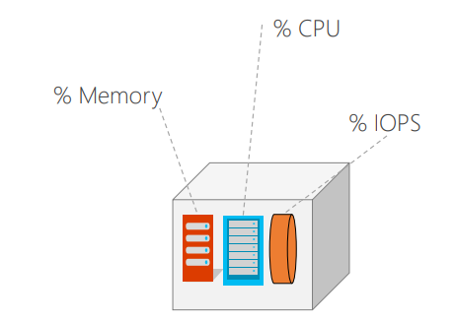

## Cosmos DB Scaling

Azure Cosmos DB's seamless scaling capabilities empower your applications to handle growing workloads with ease. Scale your database resources up or down as needed, ensuring high availability and low-latency access for users.

## Azure Cosmos DB - Consistency Levels

Choose the right consistency level for your application's data needs. Azure Cosmos DB offers a spectrum of consistency options, from strong to eventual, enabling you to strike a balance between data accuracy and system performance.

SQL Queries, Sps and Functions

## Querying Database with Azure

Harness the power of Azure to query databases effortlessly, unlocking real-time insights and data-driven decision-making. Azure's advanced querying capabilities ensure you access and analyze your data with speed and precision.

## Stored Procedure Management in Azure

Azure empowers you to streamline database operations by efficiently managing stored procedures. With Azure's comprehensive tools and resources, you can optimize performance, security, and reliability in executing complex database tasks.

## User-Defined Function Optimization with Azure

Elevate your application's efficiency with Azure's user-defined function optimization. Leverage Azure's cutting-edge technologies to create, deploy, and fine-tune custom functions, enhancing the agility and scalability of your data-driven solutions.

Creating & Managing Azure Web App

## Azure App Services

Azure App Services is a fully managed platform for building, deploying, and scaling web apps, mobile apps, and APIs. It provides a seamless environment for developers to focus on coding while Azure handles infrastructure management.

## Azure Web Apps

Azure Web Apps, a subset of Azure App Services, offers a scalable and reliable platform for hosting web applications. It supports various programming languages and frameworks, allowing developers to easily deploy and manage their web applications in the cloud.

### Azure Web Apps Features

Azure Web Apps come equipped with features like automatic scaling, continuous integration, and traffic routing, enabling developers to efficiently deploy, monitor, and maintain their web applications in a highly customizable environment.

### Azure Web Apps: Deploying Web Apps

Deploying web apps on Azure Web Apps is a streamlined process that involves configuring deployment slots, setting up continuous integration, and using various deployment methods such as Visual Studio, FTP, or Git for efficient application deployment and management.

## How to deploy a Web App?

Deploying a web app on Azure is simplified through the Azure Portal, where you can set up deployment slots, configure CI/CD pipelines, and select your preferred deployment method, ensuring a smooth and efficient web app deployment process.

## Azure Mobile Apps

Azure Mobile Apps is a cloud service designed to streamline mobile app development by providing features like offline data synchronization, push notifications, and user authentication, simplifying the creation of feature-rich mobile applications.

## Azure Logic Apps

Azure Logic Apps is a serverless, visual workflow automation service that allows you to create and manage workflows to automate business processes. It integrates seamlessly with various Azure services, SaaS applications, and on-premises systems.

### Azure App Service Environment

Azure App Service Environment (ASE) is a premium service offering that provides a fully isolated and highly scalable environment for running your apps. It's an ideal choice for organizations with strict security and compliance requirements.

## Types of App Services

* Web Apps
* Mobile Apps
* API Apps

## App Services Tiers and Pricing

Azure App Services offer different pricing tiers, including Free, Shared, and dedicated plans (Basic, Standard, Premium, and PremiumV2). These tiers vary in terms of features and performance, allowing you to choose the right plan for your needs.

## Limitations of App Services

* Resource Constraints
* Scaling Boundaries

## Web App Settings and Configuration

Azure Web Apps offer extensive settings and configuration options, allowing you to customize your app's environment, set environment variables, and manage connection strings, ensuring optimal performance and security.

## Traditional Webhosting vs. Hosting with Web App

Comparing traditional web hosting to hosting with Azure Web Apps reveals the advantages of cloud-based hosting, including scalability, easy management, and seamless integration with other Azure services, making it a more modern and efficient choice.

## Web App Deployment - Visual Studio, FTP

Azure Web Apps support various deployment methods, such as Visual Studio integration, FTP, and Git, making it convenient for developers to choose their preferred deployment approach for web applications.

## Deployment slots

Azure Web Apps offer deployment slots, which allow developers to create staging and production environments for their applications, enabling testing and seamless deployment without affecting the live app.  


## App Services Scaling

Azure App Services enable easy scaling of your applications, allowing you to handle increased traffic or resource demands by adjusting the number of instances or upgrading to a higher pricing tier.  
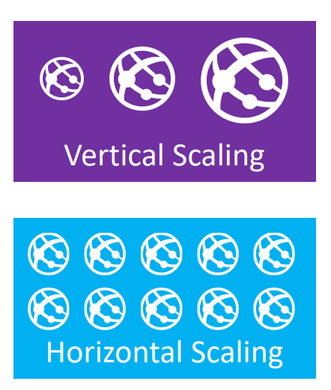

## Setting Custom Domain

You can set up a custom domain for your Azure Web App, giving it a branded web address. This helps create a professional online presence for your application and ensures a seamless user experience.

Building CI/CD pipeline using Azure DevOps and Web App

## Introduction to Azure Pipeline

Azure Pipelines is a robust DevOps service that streamlines the software development process by automating build, test, and deployment workflows. It integrates seamlessly with Azure and supports various programming languages and platforms.

### Azure Pipeline Structure

Azure Pipelines are structured around a well-organized workflow, encompassing Build Pipelines and Release Pipelines. Build Pipelines compile and package code, while Release Pipelines manage deployment to different environments, ensuring a structured and efficient development process.

### Azure Pipelines Platform Support

Azure Pipelines offers broad platform support, catering to diverse needs with CI/CD capabilities for web apps, ASP.NET Core projects, and more. It is versatile, enabling teams to work with various technologies and deployment targets.

## Understanding CI/CD

Continuous Integration (CI) and Continuous Delivery (CD) are pivotal in modern software development. CI automates code integration and testing, while CD ensures a smooth, automated path from code to production, enhancing development efficiency.

### Continuous Integration

CI is a development practice where code changes are automatically integrated and tested regularly, promoting collaboration and early issue detection, thereby improving code quality.

### Continuous Delivery & Continuous Deployment

Continuous Delivery (CD) focuses on automatically preparing code for release, allowing manual approval before deployment. In contrast, Continuous Deployment (CD) automatically deploys code to production, reducing manual intervention.

## Azure Build Pipeline

Azure Build Pipelines automate the build process, from compiling code to packaging applications, creating a solid foundation for CI/CD workflows.

## Types of Builds

* Source Code Builds
* Container Image Builds
* Other Build Types

## Creating Azure Web App

Developers can easily create and deploy web applications in Azure, leveraging Azure Web Apps for a scalable, highly available solution.

### Creating and Configuring DevOps Project

Setting up a DevOps project in Azure is the initial step toward optimizing software development processes, enabling teams to collaborate effectively and manage projects efficiently.

### Creating ASP.NET Core Project

Developing ASP.NET Core projects in Azure enhances web application development, with a focus on cross-platform compatibility and performance.

## Azure Build Pipeline with Azure Web App

Integrating Azure Build Pipelines with Azure Web Apps streamlines the deployment of web applications, automating the build and deployment process.

## Azure Release Pipeline

Azure Release Pipelines ensure that software is smoothly deployed to different environments, making it easy to manage releases and coordinate deployment across stages.

### Azure Release Pipeline For Staging Environment

Staging environments are crucial for testing and validating software changes. Azure Release Pipelines facilitate the deployment of changes to a staging environment for a thorough evaluation.

## Azure Release Pipeline For Production Environment

Production environments require a controlled and reliable release process, and Azure Release Pipelines ensure a secure and efficient path to deploying software to production.

## The Complete CI/CD Workflow

The complete CI/CD workflow in Azure combines the power of Azure Pipelines, Build Pipelines, and Release Pipelines to achieve an end-to-end automated development and deployment process, from code changes to production-ready applications.

Serverless

## Serverless Architecture

Azure offers cutting-edge serverless architecture capabilities, enabling you to build, deploy, and operate serverless applications effortlessly. With Azure serverless solutions, you can embrace an end-to-end platform for streamlined development and enhanced scalability.

## Traditional Hosting vs. Serverless Hosting

When contrasting traditional hosting with serverless hosting on Azure, the difference is clear. Azure's serverless architecture eliminates the need for managing infrastructure, allowing you to focus on code rather than servers, resulting in increased developer velocity, improved team performance, and a more significant organizational impact.

## Azure Services based on Serverless Architecture

Azure provides a rich ecosystem of services based on serverless architecture, including Azure Functions, Logic Apps, and Event Grid. These services enable you to build scalable, event-driven applications with ease, harnessing the power of the Azure cloud for your serverless workloads.

Azure Functions

## Introduction to Azure Functions

Azure Functions is a serverless computing service that allows developers to run event-driven code without managing infrastructure. It enables the execution of small, self-contained functions in response to various triggers, simplifying application development and scaling.  
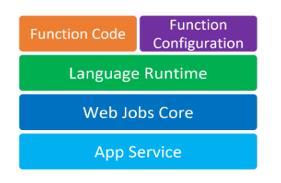

### Azure Functions Architecture

Azure Functions follow a microservices-based architecture, providing a scalable, event-driven platform. It leverages a combination of compute, storage, and event sources to execute functions as needed, ensuring seamless integration and reliable performance.

### Uses of Azure Functions

* Versatility of Azure Functions
* Azure Functions in Various Scenarios
* Real-Time Data Processing
* IoT Solutions
* Webhooks
* Serverless APIs
* Role in Modern Cloud-Native Development
* Efficiency and Cost-Effective Solutions

### Azure Functions to Build Modern Solutions

Azure Functions empower developers to create modern solutions that are responsive to real-time events, cost-effective, and easily scalable. They are instrumental in building resilient, cloud-native applications that respond to changing demands with minimal management overhead.

### Azure Function Plans

Azure Function Plans offer different hosting options for Azure Functions, including the Consumption Plan, Premium Plan, and Dedicated (App Service) Plan. These plans provide varying levels of resources and features to meet the specific needs of your applications.

### Azure Functions Consumption Plan Pricing

Azure Functions' Consumption Plan pricing is based on the number of executions, execution time, and resource consumption. It is a cost-efficient option for applications with varying workloads, as you only pay for the resources used during function execution, making it a flexible and budget-friendly choice for serverless development.

Triggers and Bindings

## Azure Function Triggers

Azure Function Triggers are event-driven mechanisms in Azure that initiate serverless function execution. They respond to various events such as Timer Trigger, Blob Trigger, Event Hub Trigger, HTTP Trigger, Queue Trigger, Generic Webhook, GitHub Webhook, and Service Bus Trigger.  
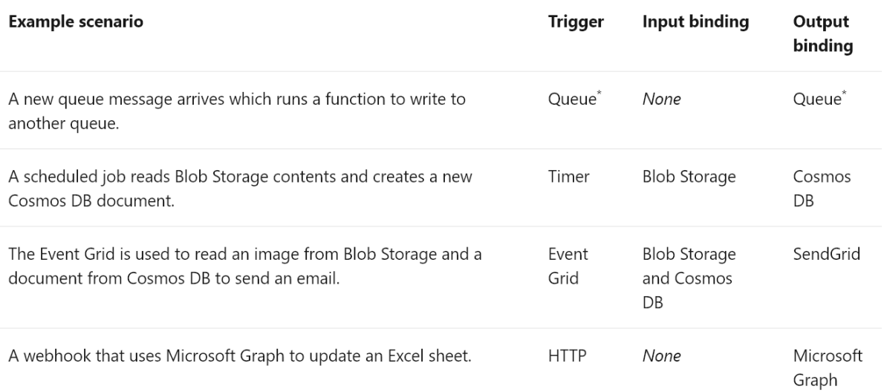

### Timer Trigger

A Timer Trigger in Azure Functions allows you to schedule function execution at specified intervals, making it ideal for recurring tasks or periodic updates.

### Blob Trigger

Blob Triggers respond to changes in Azure Blob Storage, enabling functions to run in response to new or updated blobs, providing real-time processing capabilities.

### Event Hub Trigger

Event Hub Triggers process events from Azure Event Hubs, facilitating the real-time ingestion of high-throughput data into your serverless functions.

### HTTP Trigger

HTTP Triggers enable functions to respond to HTTP requests, making it possible to build web APIs and integrate with various external services.

### Queue Trigger

Queue Triggers respond to messages in Azure Queues, allowing you to process messages as they arrive, creating efficient messaging-based workflows.

### Generic Webhook

Azure Functions can be triggered by generic webhooks, providing flexibility to respond to custom HTTP requests from different sources.

### GitHub Webhook

GitHub Webhooks trigger functions in response to events on your GitHub repositories, enabling automated actions and integrations with your code repositories.

### Service Bus Trigger

Service Bus Triggers respond to messages in Azure Service Bus, making it easy to build highly reliable and scalable messaging solutions.

## Azure Function Bindings

Azure Function Bindings allow you to connect your serverless functions to external data sources and services, simplifying data exchange between functions and external resources.

### Binding Direction

Bindings can be used for both input and output, enabling functions to read data from and write data to external sources seamlessly.

### Supported Bindings

Azure Functions support a wide range of bindings for various Azure services, databases, and external systems, simplifying integration and enhancing extensibility.

## Azure Functions Management with Serverless360

Serverless360 is a comprehensive tool for managing and monitoring Azure Functions, providing features like monitoring invocation logs and detecting failures in function invocations, ensuring the robust operation of your serverless applications.

Developing Functions Using Azure Portal & Visual Studio

## Creating a Function App

Utilize Azure's latest features to effortlessly create a Function App, streamlining serverless application development and management within your Azure environment.

### HTTP Trigger Function

Harness Azure's cutting-edge capabilities to craft an HTTP-triggered Function, enabling seamless integration and event-driven execution of code for web applications.

### Timer Trigger Function

Leverage Azure's state-of-the-art technology to build Timer Trigger Functions, empowering automated, scheduled task execution with precision and scalability.

## Developing Function Using Visual Studio

Stay at the forefront of innovation with Azure's integrated support for Visual Studio, simplifying the development of Functions through a familiar and powerful IDE.

## Creating a Function App

Effortlessly deploy and manage your Function App using Azure's latest tools and features, ensuring robust and reliable serverless application hosting.

Durable Function

## Durable Function

Experience the future of serverless computing with Azure's Durable Functions, enabling the creation of resilient and scalable workflows that persist across state transitions, all while enjoying the latest Azure innovation.  
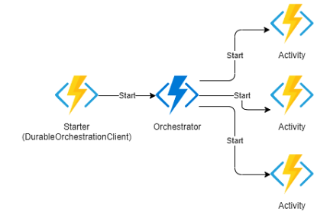

Understanding and Managing Azure Active Directory

## Introduction to Azure AD

Azure Active Directory (Azure AD) is Microsoft's cloud-based identity and access management solution. It serves as the foundation for securing and managing user identities in the modern digital landscape, offering seamless integration with various Microsoft and third-party services.

### Understanding Azure Active Directory

Azure Active Directory is a comprehensive identity and access management platform that provides authentication, authorization, and security services for cloud applications and resources. It enables organizations to manage user accounts, access policies, and secure their digital assets effectively.

## Azure AD as the Control Plane

Azure AD serves as the central control plane for managing user access and permissions across Microsoft 365, Azure services, and beyond. It offers a unified identity platform that simplifies identity governance and provides a robust foundation for securing your organization's digital environment.

## Support for Single Sign-On

Azure AD offers robust support for Single Sign-On (SSO), allowing users to access multiple applications with a single set of credentials. This enhances user productivity and streamlines access management for IT administrators.

## Getting Started with Azure AD

Getting started with Azure AD is easy, with intuitive interfaces and step-by-step guides for setting up and managing user accounts, groups, and access policies. It's the gateway to a secure and efficient identity management solution.

## Azure AD Pricing and Tiers

Azure AD offers various pricing tiers, ranging from free plans with essential features to premium tiers with advanced security and identity protection capabilities. Organizations can choose the tier that best suits their needs and budget.

## Windows Server AD vs. Azure AD

Azure AD is the cloud-based successor to the traditional Windows Server Active Directory. While Windows Server AD is on-premises and domain-centric, Azure AD is cloud-native and designed for modern, mobile, and remote workforces.

## Azure AD User Accounts

Azure AD enables organizations to create and manage user accounts, providing secure access to resources and applications. It supports user provisioning, group management, and user self-service capabilities.

## Protocol Supports

Azure AD supports a wide range of authentication and authorization protocols, including OAuth, OpenID Connect, SAML, and more. This flexibility allows seamless integration with various applications and services.

## Microsoft Graph and Azure AD

Microsoft Graph is a powerful API that connects to Azure AD, providing developers with a unified endpoint for accessing data and resources across the Microsoft ecosystem.

### Understanding Microsoft Graph

Microsoft Graph offers a consistent and efficient way to access data and intelligence from Microsoft 365, Azure, and other Microsoft services, facilitating the development of integrated and intelligent applications.

### Creating an Application

Developers can easily create applications that integrate with Azure AD, enabling secure access and data retrieval. This is crucial for building modern, cloud-connected solutions.

### Add Permission to Microsoft Graph API

To access Azure AD data through Microsoft Graph, developers need to add specific permissions to their applications, ensuring that they have the necessary access rights while maintaining security.

### Microsoft Graph API for Accessing Azure AD

Microsoft Graph API offers developers a powerful tool for retrieving user profiles, groups, and other Azure AD data programmatically, streamlining identity management processes.

### Creating Users Using Microsoft Graph API

Azure AD administrators and developers can leverage the Microsoft Graph API to programmatically create and manage user accounts, simplifying user onboarding and maintenance.

## App Authentication Using Azure AD

Azure AD provides secure authentication and authorization services for applications, ensuring that only authorized users can access application resources.

## Web App Authentication Using Azure AD

Web applications can integrate with Azure AD to enable secure user authentication, adding a layer of protection to web-based services.

## Integrating Azure AD Authentication in ASP.NET Core Web Application

Developers can seamlessly integrate Azure AD authentication into ASP.NET Core web applications, enhancing security while simplifying user login processes.

## Multi-Factor Authentication (MFA)

Azure AD supports Multi-Factor Authentication (MFA) to add an extra layer of security, requiring users to provide multiple forms of verification before accessing resources.

## Azure AD Company Branding

Organizations can customize the look and feel of their Azure AD login pages with branding, ensuring a consistent and professional user experience.

## Azure AD Reports

Azure AD provides detailed reports and insights on user activities, sign-ins, security events, and more, helping organizations monitor and improve their security posture and user management.